

1.2

ZUYD UNIVERSITY OF APPLIED SCIENCES



Workshop 1 Prepared, Safe and Secure

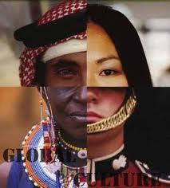

Contents

Introduction 3

Behaviour 4

Health issues 7

Things can go wrong 12

Check and double check 14

What to bring overseas? 15

Financial matters 17

Internet 19

Bibliography 20

Appendix form for those who stay at home 29

Appendix checklist 30

Appendix checklist 30

# Introduction

This workshop is an interdisciplinary gathering. This means that it is a meeting between different types of faculties, with all the participants who are going to Zambia, India or South-Africa.   
This is the second workshop offered by YPO. The main focus of this workshop is to get more knowledge about how to prepare yourself adequately for your staying overseas. Not only the do’s and don’ts, but also information about Osiris, insurances, medical services and health care issues and so on. Briefly all the practical information that you might need during your traveling and staying abroad.  
During the whole period you have to prepare your own YPO portfolio with specific assignments and forms. The assignments will be given during the whole preparation at home. You also have to do some activities during your period overseas. These activities will also appear in your portfolio.

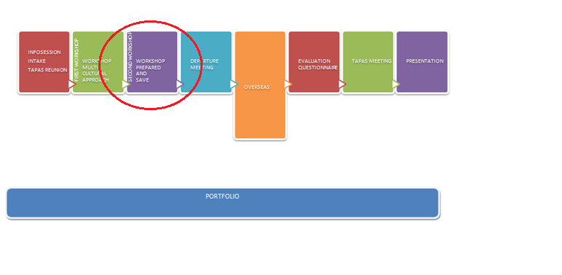

*Figure portfolio process*

Behaviour  
YPO experience with student participation abroad (provided by students themselves, contact persons of YPO abroad and feedback from teaching staff of YPO and diverse departments of Zuyd university of applied sciences) learned us to underline following competences needed to be able to function adequately in an international and cultural diverse environment. Which general competences are especially important if you are studying abroad?

YPO needs:

* An independent person, a problem solver with a flexible personality, able to adapt him/herself to cultural diverse circumstances.
* A person who is able to show empathy for poverty, and poverty related problems.
* A communicator who is able to adapt his/her communication style and attitude towards this of the receiving country/organisation/clients/customers.
* Ability to develop and show curiosity towards other viewpoints, cultural values and norms and be able to adapt yourself to other cultural patrons of communication/behaviour and living styles.
* Being able to express yourself adequately in spoken en written English
* Curiosity to other languages, other manners of verbal/ and non verbal communication. (knowing what you can say and what not (publishing information on internet e.g.)
* A team player, willing to share and care and take responsibility for other YPO members who are functioning in the same environment,
* A person who is reliable in his/her contact with the own department of Zuyd university, the organisation and stakeholders abroad and fellow YPO mates abroad.

A very important part of going prepared and safe is to knowing how to behave in a different habitat. Knowledge of the do’s and don’ts of the country and culture. You can be stubborn and think that you are a foreigner and because of that the rules do not apply to you, but you will stay in that country for several months so you must treat the people who live in that country and their culture with respect.

**Dutch directness**

In the Netherlands respect is shown through speaking one's mind and being direct. Little respect is given to those who appear devious or underhand in what they are saying. This directness of approach can often be seen as aggression or even rudeness in other countries - but is, in our opinion, a useful tool for enabling the meeting to reach an agreed solution.  
  
As with many overseas cultures, Indians and Africans find it very difficult to say 'no'. If they do, they have the feeling that they are offensive and this would mean a difficult ongoing relationship.

The moment you do end up in this situation you will across vagueness and even lack of commitment. The danger is that you will be told what people think you want to hear, rather than any uncomfortable truths. Do not attempt to force your contacts to be more direct and straightforward than they feel comfortable with otherwise you may frighten them away. Always try to be specific in your question -asking.  If you ask the question 'We are OK for the deadline on Friday, aren't we?’ the answer will probably be 'yes'.  A better question would be, “Can you tell me where we are in the process right now.”   
  
**How to dress**

One way of showing your respect is knowing how to dress. In India you don’t show your shoulders and do not wear shorts who will reveal your knees. Especially the women do not wear short skirts or tops. The local dress for women is a *sari* and consists of a blouse called *choli*, an underskirt and several meters of fabric that is folded, tucked and wrapped around the body in a way only Indian women are able to fully master. Another traditional outfit is the *salwar kameez*, a combination of a tunic top, usually called *kurta*, long pants and a loose scarf. Salwars come in many styles and colours. Young Indian women also often combine a kurta with jeans.  
In Zambia for men shorts (not too short) are fine in the bush, but long trousers are more socially acceptable in the towns and rural villages. For women a knee-length skirt or culottes are ideal. Zambia's dress code is generally conservative: a woman wearing revealing clothing in town implies that she is a woman of ill repute, whilst untidy clothing suggests a poor person, of low social standing.   
In South Africa the dress code isn’t that strict, because it is more western oriented. However , when your internship is in a formal setting you have to make sure you familiarize yourself to this. Make sure you always dress properly when you visit your internship place. Just look around and adapt to the situation.

**Sex, drugs and alcohol**

Smoking in India is seen as disrespect towards other people. Especially the women do not smoke. Never light a cigarette in front of a temple or school. When you smoke find a place to do so where other people can’t see you. In South Africa and Zambia this isn’t the case.  
Also drinking in India is less accepted than in Africa. But in all the countries the main thing to remember is that you are a YPO ambassador and an employee of your host organisation. So show yourself from a positive side. Don’t disturb the public order. Make sure you don’t get drunk in your host facility.  
In India, Zambia and South Africa roles between females and males can be perceived differently compared to the roles both actors have in the Netherlands. “Normal” behaviour in the Netherlands can be perceived as “sexual inviting” behaviour abroad. Awareness about “appropriate” behaviour in other environments can be important in order to safeguard your own safety abroad.

**Values**

Centrally located within a culture you can find the values. These are the feelings with a positive and negative side. Values have to do with how people in a culture think about good vs. evil, pretty vs. ugly, normal compared to abnormal. The values determine how people act in a culture.  
"Our" values and standards apply not just in your social environment, but also at school and your internship or work such as: be on time, appointments, leave others for what they are, listen to your teacher or boss, and provide good work. We refer to the first workshop

**Time**

The African and Indian stretchable time is a well-known statement. 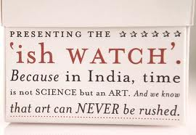In India and Africa one can replace 'fashionably late' with 'predictably late'. In India cow blockades, politician escorts, and cratered roads, compound the problem and offer a valid explanation. So when you reach 30 minutes late after the agreed time, you don't explain yourself. You wait for the other person to arrive.   
African stretchable time describes an alleged cultural trend, in most parts of Africa, toward a more relaxed attitude to time. This is sometimes used in a critical sense, about lateness in appointments and meetings. The term also is used to describe the more relaxed attitude compared to the stressful western lifestyle.

**Respect**

We say that we treat everyone with respect who will treat us with respect. Respect has both a condition of reciprocity. One condition: I treat others with respect as they treat me with respect. It is like Quid pro quo '. There is reciprocity: if someone treats me with respect, he gets respect back. In Dutch we are used to say “je and jij”. Equality between professionals or different ages in normal is the Netherlands, in Africa and India it isn’t.   
Cultural differences play a major role. Cultures can vary tremendously in expectations and status-enhancing behaviour. Therefore the quid pro quo cannot always work, because the expectations of respect differ in a culture.

**Safety**

It doesn’t matter in which country you are just always make sure you are safe. When you go out, don’t go by yourself. In the evenings take a taxi, they don’t cost much, so why take the risk? Make sure you don’t stay in ‘unsafe’ areas too long by yourself. YPO makes sure that you are never placed alone in an area and that you have a network of people whom you can contact. Therefore use this network to plan activities instead of going alone.

Identify potential risks in advance. Talk with YPO ambassadors and ask them about their experiences. Understand the guidelines and expectations from your workplace, employer and country’s perspectives. When you do feel unsafe inform your supervisor and YPO about this concern; some examples are:

* People invite themselves into your room or house;
* You receive strange and/or inappropriate text messages;
* Someone wants to bring only you in their car to a town;
* People want to take you out for dinner. (Do you know where you are going to?)

Should an incident occur know what to do; be sure to document all facts such as date, time, persons involved, and the situation as you observed it and inform your internship advisor or faculty supervisor immediately!

# Health issues

**Insurances**

When you are staying only for a short visit in another country your Dutch health insurance generally will continue. When you are staying on a long term base (6 to 12 months) the Dutch insurance most likely will stop. Partly because in municipalities it is obliged to unsubscribe yourself when you are at least 8 months or longer outside the Netherlands. Also when you perform paid activities abroad, the insurance in the Netherlands must be stopped. The insurer is the executive body. Make sure your correspondence with your health care provider is via email, so you can fall back to that information later on if necessary.

If 3 or more months paid work is done in another country than the Netherlands your insurance will be invalidate. The insurance shall also expire if you have an internship in a country where you are seen as an employee (= make use of social services there, and / or wages as compensation and expenses).

* <https://www.cz.nl/zoeken?s=cz&keywords=verlijf+in+buitenland+langer+dan+6+maanden>
* <http://www.zilverenkruis.nl/consumenten/klantenservice/buitenland/studeren/Pages/default.aspx>
* <http://www.vgz.nl/vergoedingen/buitenland/werken-en-buitenland>

When you have suitable travel insurance for internships, many important things are well-organized. Think of medical costs, like the possibly for an addition in your Dutch health insurance), emergency dental expenses, losing your luggage , accidents, search and rescue costs, costs of returning to the Netherlands because of family circumstances and so on...

It is important to determine what the coverage of your Dutch health insurance is. Often there is only limited coverage, and often the points mentioned above are not covered by health insurance. It is therefore important that you have good travel insurance.

Furthermore it is very important that you check what is covered by your travel insurance. When you take expensive cameras or phones with you, make sure the insurance covers this in case of losing them.

The most common risks that are covered by travel insurance are:

* Medical/dental expenses
* Emergency evacuation/Medical Air Evacuation/repatriation of remains
* Trip cancellation/interruption
* Accidental death, injury or disablement benefit
* Overseas funeral expenses
* Curtailment
* Delayed departure, missed connection
* Lost, stolen or damaged baggage, personal effects or travel documents
* Delayed baggage (and emergency replacement of essential items)
* Legal assistance
* Trip Cancellation
* Flight Connection was missed due to airline schedule
* Travel Delays due to weather
* Medical Emergency and hospital care (Accident or Sickness)

Of course it is something we do not want to think about, but cancellation insurance reimburses the cost of a trip if you are unable to travel. A summary of the events usually covered by the insurance, but always read the policy conditions:

* Material damage to property insured his apartment or the company where he works, so his presence is urgently needed.
* The insured under medical advice not to undergo a mandatory vaccination for travel.
* It, through no fault of the insured to, unexpected failure to obtain a required visa.
* Loss or theft of travel documents necessary for the journey of the insured on the day of departure.
* Serious illness or serious injury of the insured.
* Serious illness or serious injury of family members in the 1st or 2nd degree or household of the insured.

**Insurance Passport for Students (IPS)**

IPS offers a complete cross-border insurance policy for your stay abroad, anywhere in the world. The Insurance Passport for Students covers students, teachers and researchers going abroad to study or for exchange programs, work experience, etc. Partners and children can also be covered by IPS. The IPS insurance policy offers extensive coverage for urgent medical and dental treatment, special expenses and assistance, accidents, liability, legal assistance and loss of baggage. The cover is valid within the dates specified on your policy.

More information can be find on: <http://www.studentsinsured.com/ips/downloads/IPS%20Flyer%20EN.pdf>

**Vaccinations**

|  |  |
| --- | --- |
| **Hepatitis A** | Recommended for all regions |
| **Typhoid** | Recommended for all regions |
| **Yellow fever** | Zambia: Recommended only for those who are travelling to the North West and Western Provinces and who are at risk for a large number of mosquito bites |
| **Hepatitis B** | Recommended for all regions |
| **Rabies** | For students spending a lot of time outdoors, or at high risk for animal bites, or involved in any activities that might bring them into direct contact with bats |
| **Measles, mumps, rubella (MMR)** | Two doses recommended for all students born after 1956, if not previously given |
| **Tetanus-diphtheria** | Revaccination recommended every 10 years |
| **Malaria** | For students spending a lot of time outdoors, in areas where there is malaria, or places where there is a high risk for mosquito bites. |
| **Japanese encephalitis** | India: For travellers who may spend a month or more in rural areas and for short-term travellers who may spend substantial time outdoors in rural areas, especially after dusk |

**Medication and first aid**

[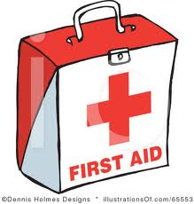](http://www.google.nl/imgres?hl=nl&gbv=2&biw=1024&bih=662&tbm=isch&tbnid=CYCBPOUOm1L34M:&imgrefurl=http://www.illustrationsof.com/65553-royalty-free-first-aid-clipart-illustration&docid=gCYPTMz_RS8HuM&imgurl=http://www.illustrationsof.com/royalty-free-first-aid-clipart-illustration-65553.jpg&w=400&h=420&ei=jQazT8D5PMjNswb3ocndCw&zoom=1&iact=hc&vpx=609&vpy=253&dur=62&hovh=230&hovw=219&tx=120&ty=125&sig=115203653167577165240&page=2&tbnh=147&tbnw=140&start=15&ndsp=20&ved=1t:429,r:3,s:1)If you travel overseas it is wise to pay attention to your health. Do you use medication? Do you wear glasses? What goes into a simple first aid kit? In countries, with different habits regarding hygiene, you could suffer different types of diseases that are not standard in the Netherlands. Make sure you have the basis medicine like anti mosquito spray and pain killers, but realize that in these countries those diseases are normal. Therefore the best medicine to get for instance for Malaria will be in the local hospital. If you have an allergy or medication is advisable to ask your doctor whether you can travel without any difficulties.   
Make sure you have enough medication with you for the duration of your trip. There are internet sites and stores like Perry Sport who have also first aid kits for travel to get there with things like bandages, gauze and betadine. Please note: if there is a pair of scissors in it you cannot stop in your hand luggage when flying.

When you travel by plane, the best thing you can do is take your medicines in your hand luggage. In the boot of the aircraft, it can be very cold and this could have effect on the medicine. In case of your luggage gets lost, you always will have your medicine. Ask a medicine passport from your drugstore before leaving. This way during checks at the airport everything can be explained.   
When you wear glasses it is convenient to bring a spare pair because is not always easy to get new glasses abroad. When you wear contacts make sure you have enough fluids and lenses with you.  
If you leave for a month or longer there is no harm in visiting a dentist in the Netherlands.

Listen to the advice given by your general practitioner at home, but also take into account that the general practitioner in the country you will stay for your period overseas is more familiar with diseases and insect bites than in the European habitat. Local treatments or medicine can be, in some cases, more effective and often less expensive. Make sure take all the advices into account and decide with common sense.   
  
**Water**

In India and Zambia it is not safe for us to drink tap water. In South Africa this can also be the case. Therefore several guidelines to keep in mind when you are overseas.

* Bottled mineral water is available in all supermarkets. Make sure you drink that mineral water and do not forget to check the manufacturing and expiry date.
* While eating out in restaurants, make sure you order bottled water only. If they serve you water in a glass that is not clean, ask for a bottle and drink from that.
* Do not drink water in plastic bags form roadside vendors.
* Do not drink tap water.
* Some places may offer you water from a hand pump. That water is equally harmful and it is not advisable that you drink it.
* While traveling in trains, it is recommended that you use bottled water for brushing and flossing.
* If staying with someone, make sure there is an aqua guard, or a water filter. If both are not available, ask for getting bottled mineral water. If that is also not possible, drink boiled water.

Not only drinking water can be harmful, keep in mind that water in swimming pools also can be unsafe. Therefore be careful with the ingestion of this water.

**HIV/Aids**

India is one of the largest and most populated countries in the world, with over one billion inhabitants. Of this number, it's estimated that around 2.4 million people are currently living with HIV. The Sub-Saharan Africa is more heavily affected by HIV and AIDS than any other region of the world. An estimated 22.9 million people are living with HIV in the region - around two thirds of the global total. Zambia, in southern Africa, has one of the world’s most devastating HIV and AIDS epidemics. More than one in every seven adults in the country is living with HIV. (Avert)

These facts above are mentioned because we want to make clear that AIDS and HIV are well known issues in India, South Africa and Zambia. These topics are not discussed in public and people will not be open towards you about these matters. There are several ways to get AIDS or HIV infection. In the everyday life there is little risk of HIV infection. Mainly due to unsafe practices with blood and semen you run the risk of a HIV infection. Infection is mainly prevented by safe sex. Important for you to be aware of possible risks and act with common sense.

Things can go wrong  
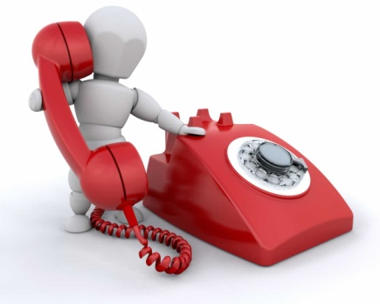To prevent calamities we want you to participate in all the YPO activities. This way we can reduce the possibilities of emergencies as much as possible. YPO provides you several items in case of calamities.  
To begin with you have to register at Osiris (see the procedure in the manual) this is very important to do, because this way we know where you stay and we have your contact information. In case of calamities we can find your information in no time. Once you are overseas it is compulsory to update your data. For example change your phone number the moment you buy a national prepaid card or change your address.   
In addition you receive a **calamity card**. This is an information card the size of a credit card. On this card you find information about the embassy, numbers of police and fire brigade. You can write down your own insurance and passport information. When a calamity occurs inform your supervisor at the internship and YPO.   
Furthermore calamities can occur in all shapes and sizes. In these cases it is important to know who to contact.

It is important to know who to call at what moment:

* Emergency phone number of Zuyd University of Applied Sciences
* Telephone number of the embassy;
* Telephone number of region coordinator and educational supervisor;
* Emergency phone number of your travel insurance;
* Phone number of your bank;
* Telephone number of your insurer.

When you are confronted with illness or an accident abroad, it is advisable to contact the Emergency Centre of your travel insurance. If you do not have travel insurance it is good to inform your health insurance.

The emergency Centre will take care of the following:

* The emergency centre maintains contact with you;
* Issuing a guarantee for the medical costs of hospital abroad;
* Organization of repatriation;
* Transport back home in case of emergency;
* If they need psychological help settle abroad.

Always check in advance your travel insurance policy conditions, so you're not faced with high costs.

**Embassy**

The Dutch Embassies are represented throughout the world. The employees of these posts look after the Dutch interests abroad. The possibilities are limited to specific help. Private Matters as account belongings are your own responsibility.

The Embassy can for example help you in case of theft of a passport or other important travel documents. They can also give advice on the transfer of money from the Netherlands, for example if your card is stolen. If you are abroad and come in contact with law enforcement, do not hesitate to contact the Embassy. In some cases you must pay for the services of an Embassy. Most Embassies have besides a general phone an emergency number where they are accessible 24 hours a day.

[](http://www.google.nl/imgres?um=1&hl=nl&biw=1024&bih=662&tbm=isch&tbnid=SZb3Z6dyrE-0zM:&imgrefurl=http://users.telenet.be/marc.hens/&docid=psTA6yRJtwz0aM&imgurl=http://users.telenet.be/marc.hens/vlag-zambia.png&w=250&h=167&ei=g_qyT-z7M83Oswbq8amKBA&zoom=1&iact=hc&vpx=615&vpy=347&dur=47&hovh=133&hovw=200&tx=105&ty=79&sig=115203653167577165240&page=1&tbnh=112&tbnw=167&start=0&ndsp=15&ved=1t:429,r:8,s:)

**Zambia**  
United Nations Avenue plot 5208, Lusaka  
Phone: +260 (0)211 253 819

[](http://www.google.nl/imgres?um=1&hl=nl&biw=1024&bih=662&tbm=isch&tbnid=1KOceC6BmHz_JM:&imgrefurl=http://www.keesenwilly.nl/Keesenwilly%20vernieuwd/De%20reis/de%20reis.html&docid=9jgLylHgjZwgjM&imgurl=http://www.keesenwilly.nl/Keesenwilly%20vernieuwd/welkom!/vlag%20zuid%20A.bmp-for-web-normal.jpg&w=320&h=213&ei=kfqyT6HOEIjQsgbDnsAs&zoom=1&iact=hc&vpx=269&vpy=314&dur=610&hovh=170&hovw=256&tx=101&ty=90&sig=115203653167577165240&page=1&tbnh=120&tbnw=180&start=0&ndsp=15&ved=1t:429,r:11,s)**South Africa**  
210 Queen Wilhelmina Avenue 0181, New Muckleneuk Pretoria  
Phone (+27) (0)12-425 4500  
Emergency info (+27) (0)83-292 0894

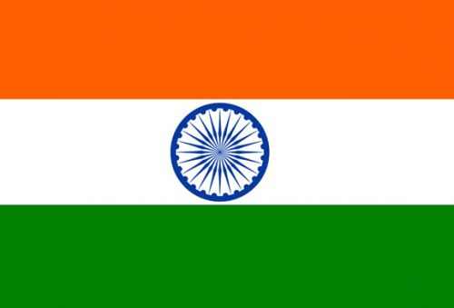**India**80/81, 7th Floor,MBC Towers, Alwarpet, 600018 Chennai  
Phone: (+91) (0)44 4211 2770

*Please write down all the information in you calamity card!*

**NUFFIC link**

[http://www.nuffic.nl/promotie/cospa-netwerk/calamiteiten?goback=.gde_4321609_member_192870460 Pagina 1 van 2](http://www.nuffic.nl/promotie/cospa-netwerk/calamiteiten?goback=%2Egde_4321609_member_192870460%20Pagina%201%20van%202)

Go to this link for useful information concerning calamities overseas!**Ministry of Foreign Affairs**

Assistance on consular level is a key task of the Ministry of Foreign Affairs. Providing advice to travellers is on example of this assistance. This helps Dutch travellers to be better prepared concerning security risks overseas. Security risks can vary from serious crime such as armed robbery to natural disasters and acts of war.

When the security situation in a country declines, it can be possible that all trips towards these countries are recommended as not advisable; these destinations are discouraged. This doesn’t mean that the Ministry gives a negative travel advice. The travel advice of the department is non-binding. You have to check this site before you leave, whether it is advisable to go or to stay. Don’t forget to check the site during your stay as well. These countries are known for their changing status.

<http://www.minbuza.nl/reizen-en-landen/reisadviezen>

There is also an App available (free) for Android, Iphone or Ipad : Bz Reisadvies App. In case of an emergency this app provides you all contact-information you’ll need.

# Check and double check

**Passports**

*Zambia:* To enter Zambia, a passport valid for six months from the visa's date of expiry is required by all nationals referred to in the chart above. *South Africa:* To enter South Africa, a passport valid for at least 30 days after the intended date of departure is required by all nationals referred to in the chart above.Passports must have at least two blank pages for entry stamps - visitors have been refused entry by airport immigration officials for flouting that regulation. *India:* Passport valid for at least 180 days and with at least two blank pages required by all nationals referred to in the chart above.

**Visa**

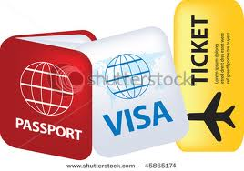Zambia, South Africa and India require *different* approaches in gaining visa. Keep in mind that the embassies can be very strict in their procedures. Yearly the protocols change. Therefore we advise a visa agency : [www.visumbureau-limburg.nl](http://www.visumbureau-limburg.nl). You can find more information at BB.

For an internship in South Africa you need a valid passport and other documents or statements. For further specific information check: <http://www.southafrica.info/travel/documents/visas.htm#basic>

A Zambian visa can be obtained from the Embassy of Zambia in Brussels. It is also possible to obtain the visa upon arrival at the airport in Lusaka. For the procedure for obtaining a visa at the Embassy of Zambia in Brussels, we refer you to their website: [www.zebru.org](http://www.zebru.org)

**Tickets**

There are several ways to obtain tickets. First of all there are agencies that can search for you. When you pay a travel agency is not necessarily more compared to the internet. The price that a provider offers via the internet is the same price as the agent. The agency will receive a commission. If you book directly, this committee keeps the fee itself.

If you like to take care of it yourself and also like to investigate things, then you can do this via internet. Keep in mind that sometimes there are many individual factors and combinations.

It is good to find out what is cheaper, but again, it does not necessarily mean that if you book everything online, it is cheaper.

Find online: [**http://www.skyscanner.nl/**](http://www.skyscanner.nl/)

# What to bring overseas?

**Laptop (also camera):** It is becoming increasingly popular to take along your laptop. There are some things though to look into before you take it with you.  
**Laptop Insurance**: A laptop is a very valuable asset. It is therefore advisable to check if your laptop is covered by your travel insurance, or if you have sign for a separate insurance for the laptop. Record the serial number of the laptop. This can, in case of theft of the laptop, save you a lot of problems occur during the declaration and payment by the insurance.  
**Internet**: If you connect your own laptop to the Internet, you can choose to dial a local ISP or your own provider. If you use a modem to dial, it is advisable to do this via a local telephone number because of the high cost of international calls. A number of Dutch providers gives you the possibility to call at local rates. It is also possible in some countries to make use of wireless internet. You'll need a wireless network card. When you don’t bring your own laptop you are dependent on the presence of internet cafes. Keep in mind that you are abroad and it is not standard that there are internet cafes in all the places or that there is WIFI available in all the hotels.

**Adapters:** In some countries there are different types of connections. It is useful before you start your journey to find out which connections are used in the country where you go. For electricity, in most cases laptops are not necessary to have a voltage converter, since most of laptops power both 110 and 220 V can handle. The plugs are often quite different than in the Netherlands. For telephony adapters you can go to the computer and telephony specialist. These stores usually have a wide range of different adapters.

**Physical protection of a laptop:** a good laptop bag that protects prevents damage during transport is very important. There are a large number of different types of bags available. Because of a laptop’s light weight they are often stolen. There are several locks and alarms for sale.

**Security of your data**: Before you travel it is always advisable to make a backup of your data and save them at your home or work place. Due to extreme heat, vibration and moisture it could be possible that your laptop does not work correctly. This allows the data on the laptop to get lost. If you have sensitive data on your laptop it you could encrypt your data. Data encryption can be done by file and disk encryption.

**Hazardous substances**: It is prohibited to carry hazardous substances or things in your bags. That means no Drugs (or items to consume drugs with), explosives, weapons and ammunition. At the airport it is possible to seal your luggage. This way you are sure nothing you don’t want in your suitcase will get in.  
**Clothes:** Do not bring to much clothing, for the reason that you can find enough clothes overseas to wear. Internship companies appreciate the effort to wear traditional clothes of the country.   
**Far away from home:** You need to adapt; eat the food, listen to the music, wear the clothes, make friends. However, it is important that you bring items to make yourself feel at home. That can be different for each person. Maybe some music pictures or candles can make you help feel at home far away from home. Some students prefer their own blankets to sleep in. it is all a matter of personal taste  
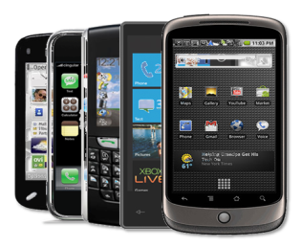**Wealth:** Having a Smartphone or laptop can be seen as a symbol of wealth. Be aware of that! Don’t flash your items and keep your money safe. Be prudent walking around with your laptop or Smartphone with earplugs. These are precious devices. It could be a reason you or a fellow student get robbed.

# Financial matters

**IB group**

When you still live with your parents you can ask for a ‘living away from home” grant. This grant is higher than when you live with your parents. Applications for grants must be done via login on the site of DUO. You need a DigiD with SMS function. DUO recommends that you ask at least three months before the date of your internship for any additional grants. When you go overseas for an internship and you remain registered with Zuyd it is possible to apply for a monthly fee with the form Application fee OV abroad. Apply for the fee at least two months before you go abroad. Zuyd university must certify on the form that your internship or study abroad counts towards your study in the Netherlands.

*Please note: The fee may be granted only for the months in which you do not use the student products.*

[*http://www.ibgroep.nl/Images/8731_tcm7-411.pdf*](http://www.ibgroep.nl/Images/8731_tcm7-411.pdf)

**Pin and Credit card**

It is not necessary to take foreign money with you, because it is possible to use your bankcard at the airport. Make sure it is an international – worldwide card. You can ask your bank if you have a correct card for abroad.   
Overseas it can happen that you are in a store and it is not possible to pay with your card, because the people are not familiar with the phenomenon of "pins" and only accept cash. Therefore make sure that you always have enough cash with you, but keep the ‘large’ and the ‘small’ money separated. This way your entire wallet isn’t visible the whole time.

An automated teller machine or automatic teller machine (ATM) is a cash point.   
Twenty-four hour ATM's are found in most large towns and cities. The most commonly   
accepted cards are MasterCard, Cirrus, Maestro and Plus. You can also pin   
with your VISA or other credit card but be aware of extra costs. (Approximately €4, 50 per transaction) Away from major towns is it wise to take cash or travellers cheques as back-up with you.

**Bankcard**

For security reasons your world bankcard may be blocked for use outside Europe. Before departure you should check this with your bank. It has to be unblocked otherwise you *not* be able to draw money from ATM machines overseas.

**ISIC**

The International Student Identity Card (ISIC) gives you the opportunity to receive discounts and services at home and around the world. The ISIC card is an internationally-recognised student ID and ISIC card holders are members of a global club. You'll use your ISIC card to save money as you travel the world and it's just as useful back home. There are tens of thousands of student discounts on offer, so check what's available at your local restaurants, cinemas and shops. The ISIC card is a real student lifestyle card. There are offices all around the world which will issue your ISIC student card. All you have to do is bring proof that you're a student, and a passport-sized photo.

On <http://www.isic.org/> you can see what discount possibilities you have.

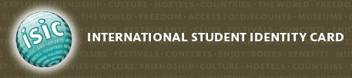

# Internet

**Available or not**

As mentioned before it is not standard that there are internet cafes in all the places or that there is WIFI available in all the hotels. Especially during the Indian introduction week there will be only a few moments were you can reach your family and friends.

**Drop box**

[](http://www.google.nl/imgres?hl=nl&gbv=2&biw=1024&bih=662&tbm=isch&tbnid=HZZq6q22K8vwAM:&imgrefurl=http://www.apple4ever.nl/2011/04/18/dropbox-verwerkt-nu-200-miljoen-bestanden-per-dag/&docid=_ywnZ1dhoBouMM&imgurl=http://www.apple4ever.nl/wp-content/uploads/2011/04/dropbox.png&w=2000&h=678&ei=0wezT4ftGcfFtAaT-smwBA&zoom=1&iact=hc&vpx=595&vpy=184&dur=47&hovh=131&hovw=386&tx=266&ty=81&sig=115203653167577165240&page=1&tbnh=61&tbnw=180&start=0&ndsp=15&ved=1t:429,r:4,s)Dropbox is a free service that gives you the possibility to save your photos, documents and videos online. Files uploaded to Dropbox via the [desktop application](https://www.dropbox.com/install) have no file size limit. Files uploaded through the [website](https://www.dropbox.com/home) (by pressing the **upload** button) have a 300 MB cap. In other words, each file you upload through the website must be 300 MB or less. Your files are actually safer while stored in your Dropbox than on your computer in some cases, because they have the same secure methods as banks.

**Literature**

Of course you need to do research and have to study during your internship or graduation project. But to take all your books with you will be impossible. Therefore we advise you to discover what books you will need and make sure that you have these books online. Some faculties offer online books via the library. You can find books and study material on the internet.

**Facebook**

# Bibliography

Affairs, S. i. (2012, 03 16). *South Africa Info*. Retrieved 04 24, 2012, from South Africa Info: http://www.southafrica.info/travel/documents/visas.htm#basic

Brussels, Z. E. (2012). *Embassy of Zambia*. Retrieved 04 24, 2012, from Embassy of Zambia: www.zebru.org

BuZa, M. (n.d.). *Ministerie BuZa*. Retrieved 4 24, 2012, from Ministerie BuZa: http://www.minbuza.nl/reizen-en-landen/reisadviezen

*Dropbox*. (n.d.). Retrieved 04 24, 2012, from Dropbox: https://www.dropbox.com

*DUO-IB Groep*. (2012). Retrieved 04 23, 2012, from DUO-IB Groep: http://www.ib-groep.nl/particulieren/reizen/buitenland.asp

ISIC. (n.d.). *International Student Identity Card*. Retrieved 04 24, 2012, from International Student Identity Card: http://www.isic.org/

Media, C. (2012). *Dutch Communication Styles*. Retrieved 04 24, 2012, from World Business Culture: http://www.worldbusinessculture.com/Dutch-Business-Communication-Style.html

*reisverzekeringen*. (n.d.). Retrieved 04 24, 2012, from Independer: http://www.independer.nl/reisverzekering/faq/top-10/wat-vergoedt-een-annuleringsverzekering.aspx

*reisverzekeringenblog*. (2010, 12 03). Retrieved 04 24, 2012, from reisverzekeringenblog: http://www.reisverzekeringblog.nl/hulp-buitenland-ambassade-alarmcentrale

Rijksoverheid. (n.d.). *Rijksoverheid*. Retrieved 04 24, 2012, from RIjksoverheid: http://www.rijksoverheid.nl/onderwerpen/zorgverzekering/vraag-en-antwoord/ben-ik-verzekerd-voor-de-zorgverzekering-als-ik-in-het-buitenland-woon.html

Rijksoverheid. (n.d.). *Rijksoverheid*. Retrieved 04 24, 2012, from Rijksoverheid: http://www.rijksoverheid.nl/onderwerpen/wijs-op-reis

*The IPS insurance*. (n.d.). Retrieved 04 23, 2012, from The IPS insurance: http://www.studentsinsured.com/ips/downloads/IPS%20Flyer%20EN.pdf

*what to wear in India*. (2009, 07). Retrieved 04 24, 2012, from South Asia/China travel: http://satu-susanna-rommi.suite101.com/what-to-wear-in-india-a176574

*what tot take*. (n.d.). Retrieved 04 24, 2012, from Zambia travel guide: http://www.zambia-travel-guide.com/bradt_guide.asp?bradt=1111Appendix Osiris International

It is compulsory to enrol your internship or graduation project via Osiris Student. Before completing the data on Osiris, **please make sure you have finalized all your documents in a digital way (passport, visa).**

Start with: <https://osiris.hszuyd.nl> sign in as usual and click on”Buitenland”. In English it says “Stay abroad”.

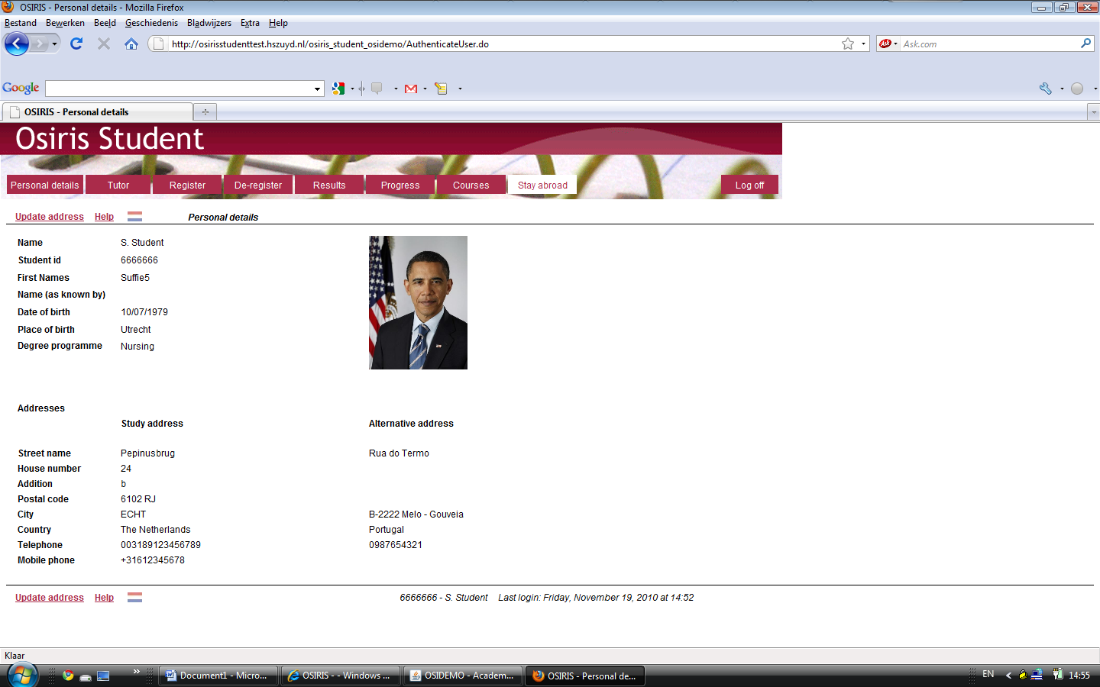

1. 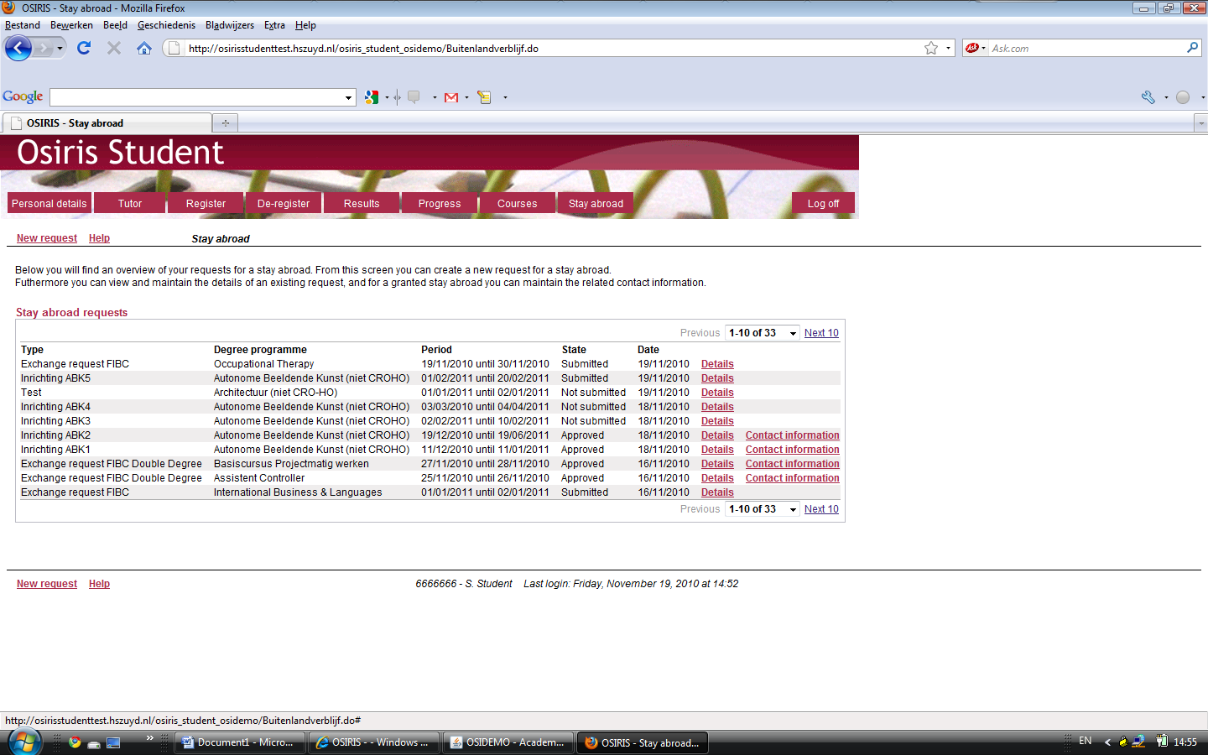Then, click on “New request” at the bottom left on the page.
2. On this page you need to fill in the details regarding your request in Osiris for an external stay abroad. Required fields are marked by a *.

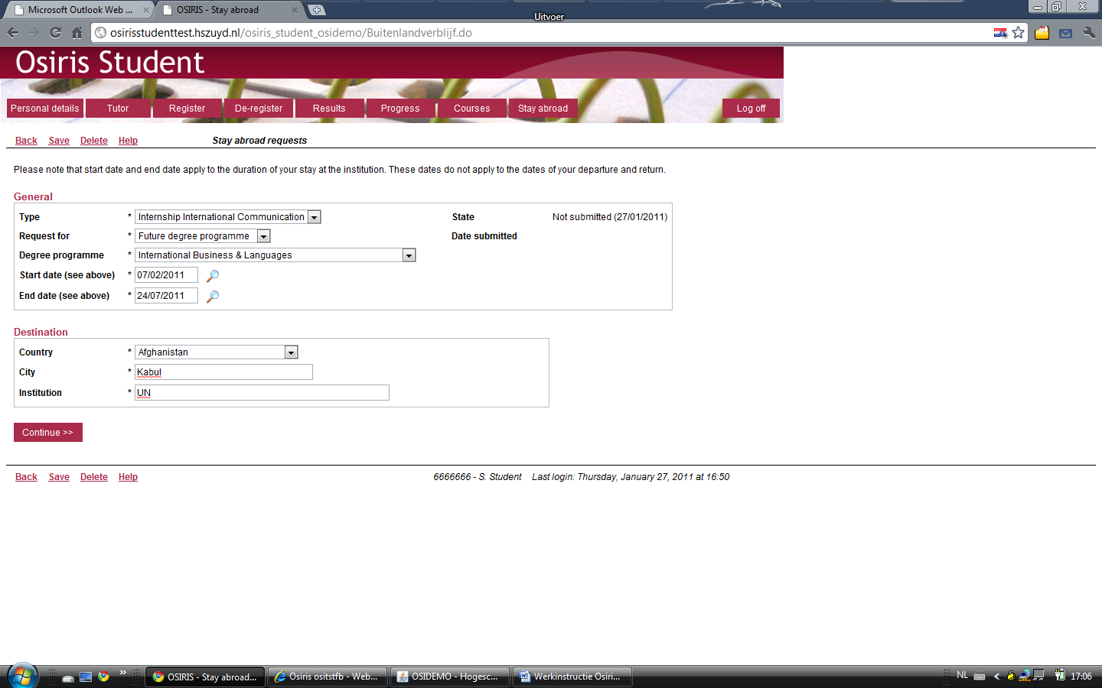

How to fill it in:   
  
*General*Type: Select the item you want to enrol in  
Request for: Select “**Current degree programme**”   
Degree programme: Choose: Young Professionals Overseas  
Start date and End date: Enter the correct dates for your internship  
  
*Destination*Country: Select the correct country: Zambia/South Africa/India  
City: Fill in the correct city  
Company/organisation: Fill in the company/organisation of your choice.

The company/ institution is to meet the internship requirements of your study programme and subject area.

Please click on “Continue” to go to the next page.

1. On this page you need to fill in the additional information we need from you.   
   You can (if possible/or available for your studies) upload a document by clicking on the “**Add**” button. Keep in mind that this is compulsory; therefore make sure you have a copy of your passport.

**If you don’t have a scan just make a picture with your Smartphone or digital camera.**

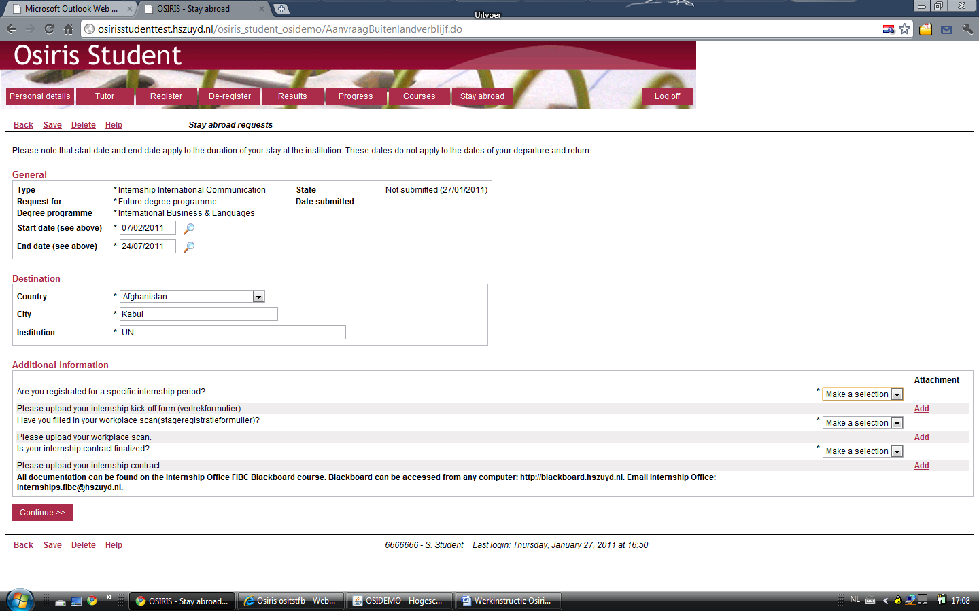

Once finished, please click on “Continue”.  
  
Note:   
You can choose to save data (by clicking the “Save” button) and continue. All changes will be automatically saved.  
  
 You can also choose to delete data (by clicking the “Delete” button) and make a new request. Only requests, which have not been submitted, can be deleted.

1. The last step before submitting your internship documentation is to check whether all required fields have been filled in correctly. If it is all right, please click on the “Submit” button below.  
   If it is not all right, click on the “Back” button to go back to the previous page where you can fill in the correct data.

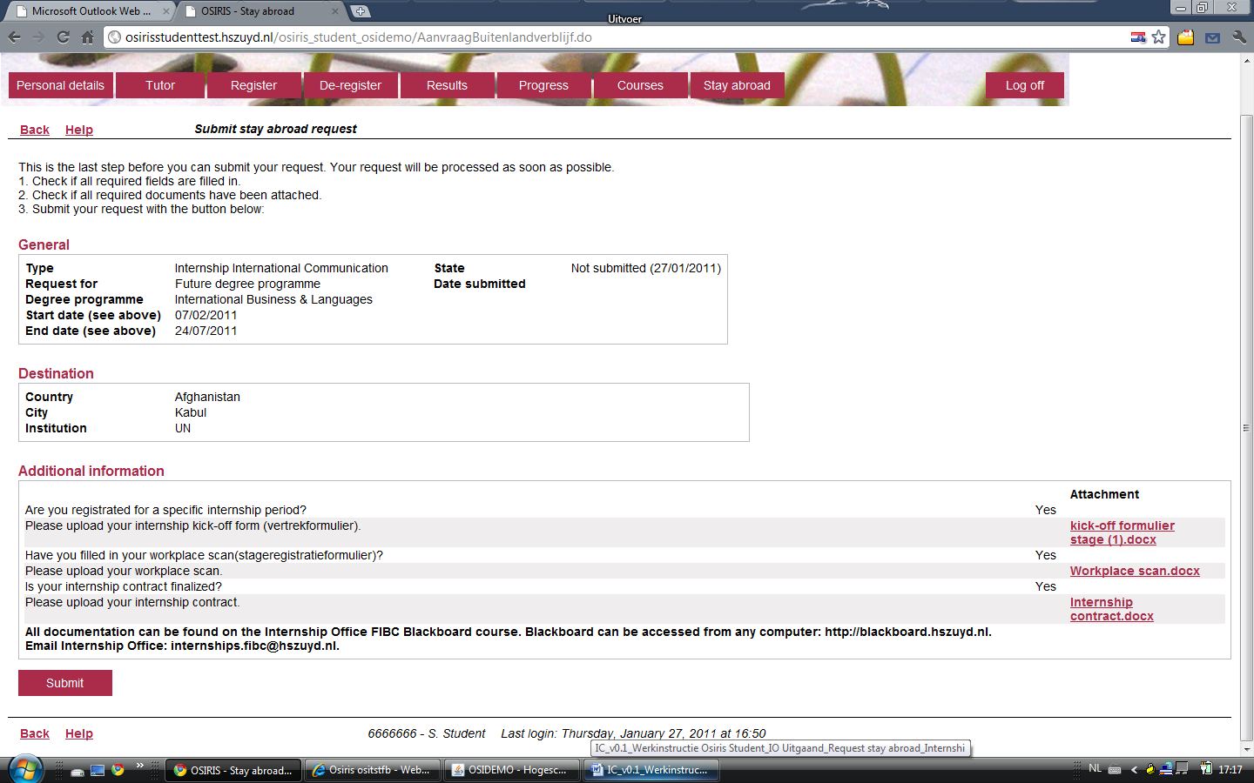

After submitting your request you will receive a confirmation of your enrolment via e-mail. It can take up to half an hour before you receive this information.

On your screen, the status of your request has been changed to”Submitted”.

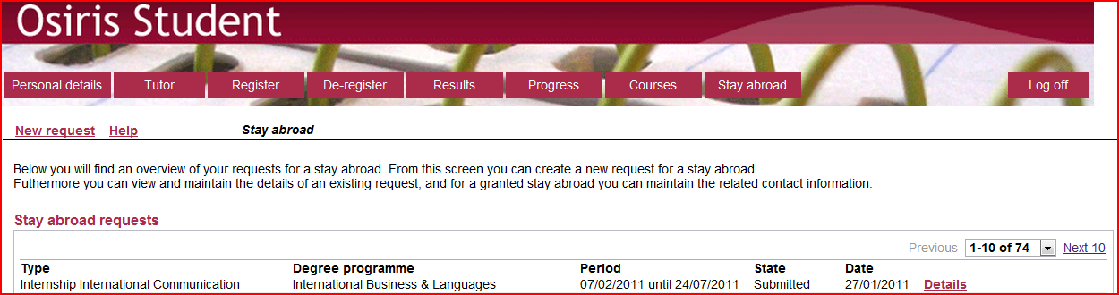

**Internships - Contact Information**

As soon as the Internship Office abroad has approved your request for a stay, you will receive a confirmation via e-mail. In addition you need to fill in all relevant contact information for your stay abroad.

1. Go to Osiris Student (<https://osiris.hszuyd.nl>), sign in as usual and click on”**Buitenland**” (in English it says”Stay abroad”).



1. 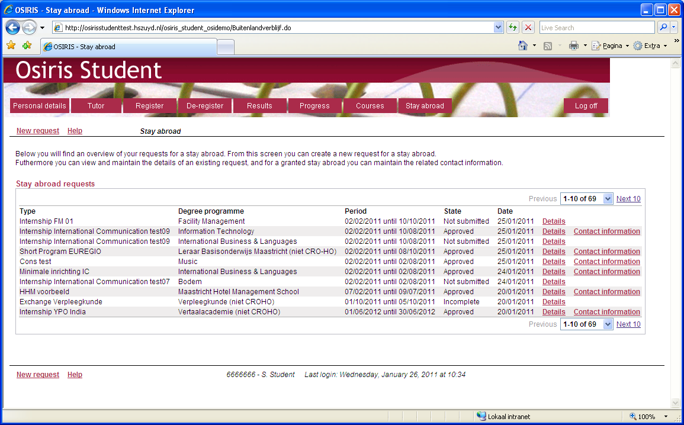The status of your request has been changed to”**Approved**”. Click on”Contact information” to go to the next page.
2. On this page you need to fill in the contact details for your stay abroad. 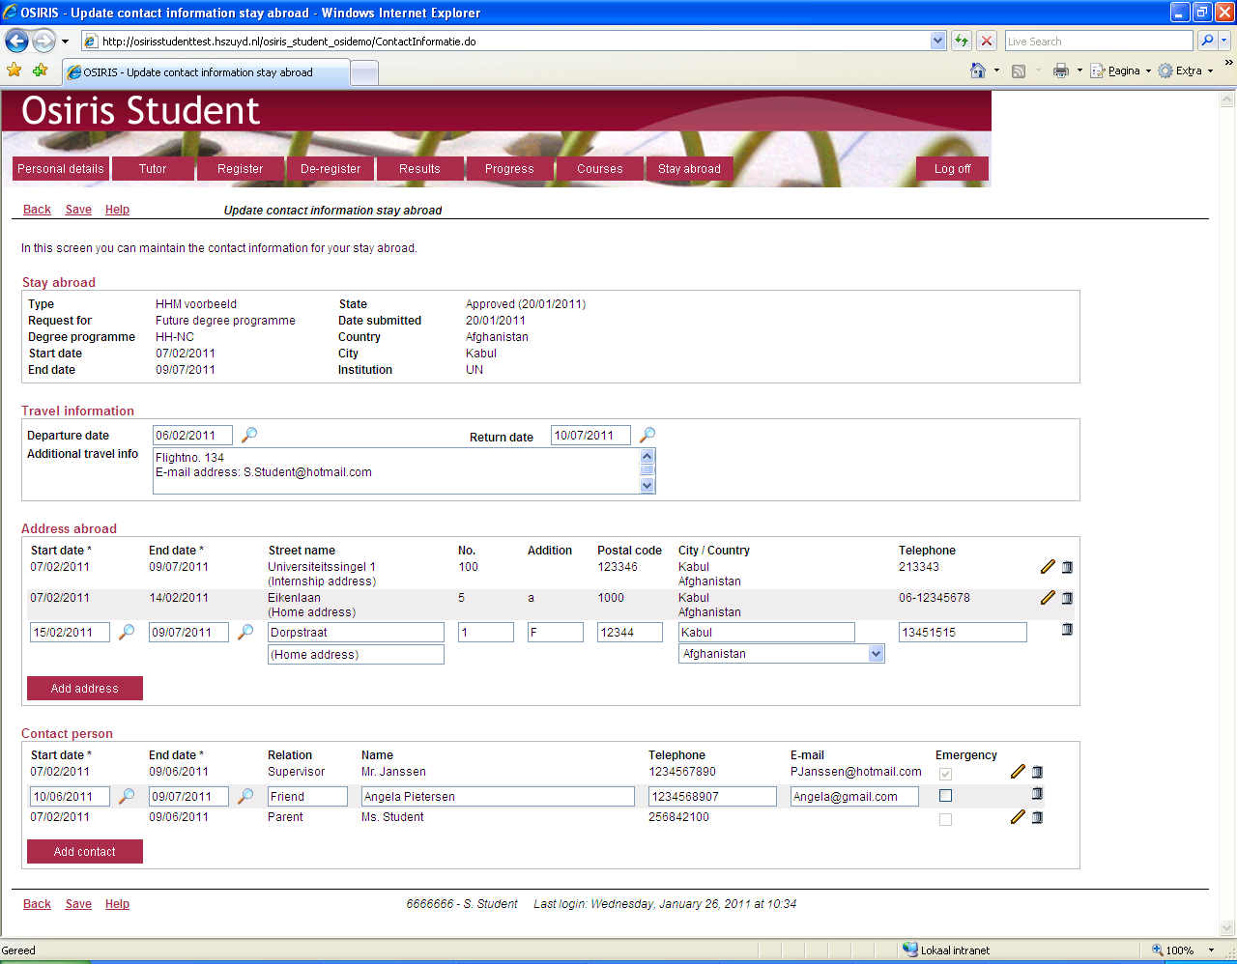

How to proceed:

*Travel Information*In this section you can edit your travel dates and additional travel information, for example your flight number or your personal e-mail address.

*Address abroad*In this section you can edit your residence addresses. Each address requires a start date and an end date. You can add a new address by clicking the ”Add address” button. The pencil and trashcan icons can be used to edit or delete an address.   
In the second field below ”Street name” you can fill in additional information regarding the address.

*Contact person*In this section you can edit contact persons. Each person requires a start date and an end date. It is important that you fill in your relation to the contact person, for example parent, friend, supervisor or tutor. Do not forget to fill in the name and the email address of your company- supervisor.  
The check box “Emergency” should be ticked for only one contact person. A telephone number is required for an emergency contact person. You can add a new contact person by clicking the ”Add contact” button. The pencil and trashcan icons can be used to edit or delete a contact person.

1. When all required fields are filled in correctly, please click the ”Save” button to store the data. You can adjust your contact information any time.

# Appendix form for those who stay at home

|  |  |
| --- | --- |
| Living address overseas | Street name  Postal code  Region |
| Phone number overseas | Number |
| Host organisation’s address overseas | Street name  Postal code  Region |
| Name on-site supervisor | Name  Function |
| Name educational institution | Zuyd University of applied Sciences |
| Name educational supervisor |  |
| Contact person YPO | Region Coordinator |
| Address student office  Phone number Tamara Nhkata | Brusselseweg 150 6217 HB Maastricht 0031641829008 |
| Health insurance contract number | Name Number |
| Travel insurance contract number | Name Number |
| Passport number  BSN number  Valid from/till |  |

# Appendix checklist

***Clothes***

glasses

trousers

fleece

sneakers

jacket

boats

underwear

cap/hat

pyjamas

belt

shoes and slippers

socks

sweaters

t-shirts

hiking shoes

handkerchief

***Technical equipment***

batteries and adapters

cell phone

camcorder

worldwide plug

hairdryer

camera

I-pod

game console

binocular

clock radio

flash light

***Medicine***

medicine

nasal spray

first aid kit

compeed bandages

earplugs

tick pliers

refreshing towels

sunscreen

after sun

mosquito repellent

diarrhea blockers

***Papers***

addresses

money

reading books

paper and pen

passport alternative

drivers license

travel guide

copies of important documents

calamity card

vaccination book (yellow passport)

***Sleep***

little mirror

toiletries

hair brush

nail cutting kit

shampoo + conditioner

facial wash and cotton pads

tooth paste and brush

make-up

contact lenses + accessories

***Other matters***

hand crème

needle and tread

umbrella

backpack

games and cards

candies against air pressure

padlock for backpack

waterproof bags

good mood