Young Professionals Overseas, is an international programme of Zuyd University of Applied Sciences. Several times a year, the programme places multidisciplinary groups of Zuyd students in internship or graduation projects in India, Zambia and South Africa.
The main focus of the programme is to encourage and facilitate students to broaden their perspectives overseas; fostering global responsible citizenship along the way! A multidisciplinary and sustainable approach make this award-winning* programme unique among other international programmes.
Young Professionals Overseas is run as a student company. This means that both teachers and students form a team during all the processes of the placements, ranging from the giving of information sessions to participating in the final evaluations. The Young Professionals Overseas programme
is open to all students and staff of the institution.
*YPO won the Orange Carpet Award 2013, an award from Nuffic (Netherlands organisation for cooperation in higher education) given every year to special initiatives in the area of internationalization in universities and Universities of Applied Sciences.

1+1+1+1=10
Young Professional Overseas is characterized by 4 features
- Demand driven: our projects are primarily focused on the demands of the organizations overseas.
- Sustainable: we focus on forging a relationship with all our partners abroad; this is made possible by choosing specific regions. By sending students and staff on a regular basis we are able to maintain projects on a sustainable basis.
- Multidisciplinary: YPO students become part of multidisciplinary groups. This is a unique way to enlarge and share professional competences within several projects overseas.
- Prepared and safe: we take care of proper preparation and safety measures.
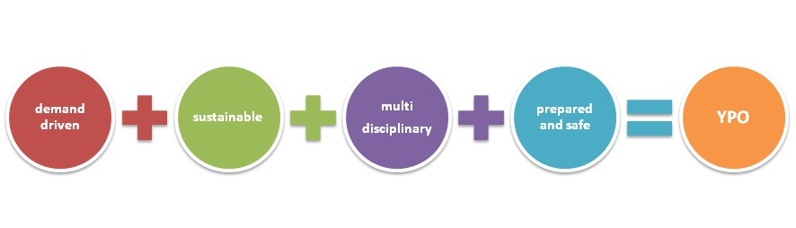
Aims and approach
We arrange internships and graduation projects for bachelor (University of Applied Sciences) students in both profit and non-profit organizations. By concentrating on placing participants in selected regions, Young Professionals Overseas provides efficient service in secure environments. YPO aims to encourage students and staff to travel to distant countries and to encounter totally different cultures, by removing barriers which cause uncertainty. Security precautions are taken both before and during the stay overseas to reduce risks. In case of calamities YPO knows that it can rely on its partners overseas.
YPO brings multidisciplinary students and staff together at Zuyd in the Netherlands. Following adequate preparation they go abroad in groups. Students are challenged to cooperate within a multidisciplinary group and to participate in multiprofessional projects, learning to adapt to all kinds of circumstances. Skills and attitudes are mastered which will serve any future career.
To prepare students adequately at home
YPO takes preparation seriously which makes all the difference. First of all, a multicultural approach is chosen to start preparations. Topics such as recognizing and adapting, self-perception, being culturally sensitive, anticipating culture shock and understanding community based rehabilitation in other cultures are examples of the subject matter covered in preparation workshops. Furthermore, we provide advice which provides a basis for a secure and healthy stay overseas and help students with assembling necessary travel documents.
To support students adequately overseas
During their stay overseas, students will not be on their own. Upon arrival they will participate in an introduction programme together with YPO staff and local YPO organizations. With the other YPO peers they will be faced with a new ambiance and circumstances. Soon the students form a small community overseas. YPO strives to visit all students while they are abroad. During their stay abroad students keep in touch with the YPO staff and their specific academic programme internship coordinator by e-mail, telephone or Skype. Midterm briefing and reflection weekends with the group are encouraged. YPO focuses mainly on the process, intercultural development and personal well being of the students. The specific internship coordinator of the students’ faculty focuses on the professional development. In the background, the student company offers support to students and staff if desired.
To engage in social responsibility
YPO engages in social responsibility in several projects, by working together with non-profit partner organizations. That means that students and staff participate in demand driven societal projects and assignments overseas to become global responsible citizens.

YPO in 8 steps
The YPO process functions within an 8 step logistic frame which assures students support and supervision
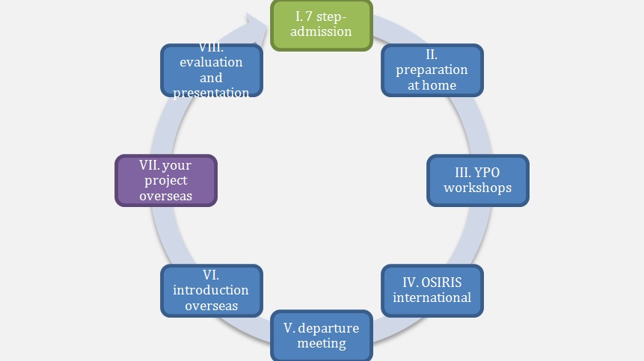
Contact
e-mailaddress: ypo@zuyd.nl
www.facebook.com/YoungProfessionalsOverseas
Zuyd University of Applied Sciences
International Office - Brusselseweg 150, 6217 HB Maastricht
Postal address: Postbus 634, 6200 AP Maastricht
The Netherlands

