

Workshop 2 Multicultural Approach

**1.4**

ZUYD UNIVERSITY OF APPLIED SCIENCES



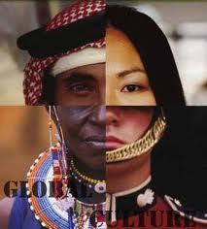

Table of Contents

Introduction 3

Learning objectives 4

Intercultural communication 5

What is perception? 5

Physical Personality Behaviour 5

Leary’s circle 6

Right and wrong 6

Hofstede’s Dimensions 7

Fons Trompenaars: the car and the pedestrian 8

Edward Hall 8

Hall’s Cultural Contexts 8

Hall’s time dimensions 8

Success factors 9

Assignments **Fout! Bladwijzer niet gedefinieerd.**

Assignment A: Identity circle 10

Assignment B: Leary’s circle 10

Assignment C: Interview 10

Assignment D: Own expectations 11

Assignment E: Culture clashes 11

Bibliography 12

# Introduction

Going abroad entails more than simply changing countries. In the forthcoming first workshop about cultural diversity we focus on the knowledge, skills and attitude you now possess and those which you will need in other cultural environments. Experience has shown that improving efficiency is only possible if people are able to behave in an appropriate cultural manner. Therefore we invite you to be an active participant in the YPO cultural workshop. In order to maximize the output of the workshop, it is necessary for you to prepare yourself adequately by fulfilling the assignments below.

Hilde van Schaeren and Bonnie Weinstein will present this workshop and will give you more information about culture and practical examples about cultural differences.

The book Cross cultural communication written by Anka Jacobs is a hands-on book which is practical to read and essential for this workshop.  
Our wish to connect with other individuals is universal, yet breaking through cross-cultural communication barriers can be difficult. By reading this book you will learn to recognize that the cause of international miscommunication often finds its roots, not in disrespect, but in different cultural conditioning.

In this manual you’ll find a brief summary of topics discussed in the workshop. Furthermore you will find the assignments related to multicultural aspects. On blackboard is the most recent PowerPoint version available of this workshop. If you have any questions contact us at [ypo@zuyd.nl](mailto:ypo@zuyd.nl)

# Learning objectives

*Learning objectives*

* To adopt professional skills within cultural different environments

*How are we going to achieve this learning objective?*

Cultures don’t meet, people do (Hoffman, E. 2009),

*That’s why we first focus on:*

* Who are you? What is your identity? (Or understanding of yourself)
* Who are you going to meet abroad?
* What is your own communication style? What are the similarities and possible differences of other communication styles?
* Communication: the relation between knowledge, perception, behaving and attitude.
* Cultural diverse orientations: use of time/space/relationships/religion-nature/human activity

*Crossing Borders*

Some of you already participated in the subject Crossing Borders. This can signify that you have overlapping topics concerning the first workshop. However another goal, besides gaining knowledge, is to meet your fellow students and YPO staff members. Also by interactive activities you get to know yourselves better before travelling overseas. Therefore this workshop is obligatory for all the students**.**

**If you do not attend this workshop an extra assignment will be consigned to compensate this part of the YPO cycle!**

# Intercultural communication

When we study intercultural communication we realise that people from different countries and cultures behave, communicate, and perceive the world around them in a unique way.

## What is perception?

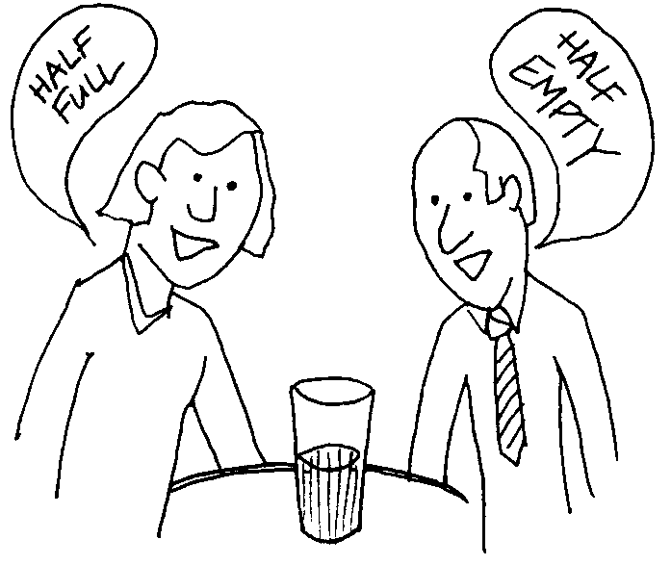Our brains cannot take in everything so we look at the general situation and react. We react in a standard way to standard situations using standard actions. How we react is based on our judgments, our decisions, is our identity.

## Physical Personality Behaviour

How do others identify us? Physical appearance, personality, education, behaviour, it is top of the iceberg. People’s external perceptions and our internal feelings often differ; people do not know how you feel. And the inverse may be true! What you perceive of a person isn’t the whole story we have to dig deeper. One way to do that is knowing our characteristics, values and beliefs, and behaviours and getting to know those of others.

* Communication is all about interactions with others. From person A to person B
* Insight in your own communication style allows understand/influence reactions of others.
  + E.g. CLOSE THE DOOR YOU SILLY COW!
  + Please, will you be so kind as to close the door? (friendly voice)

# Leary’s circle

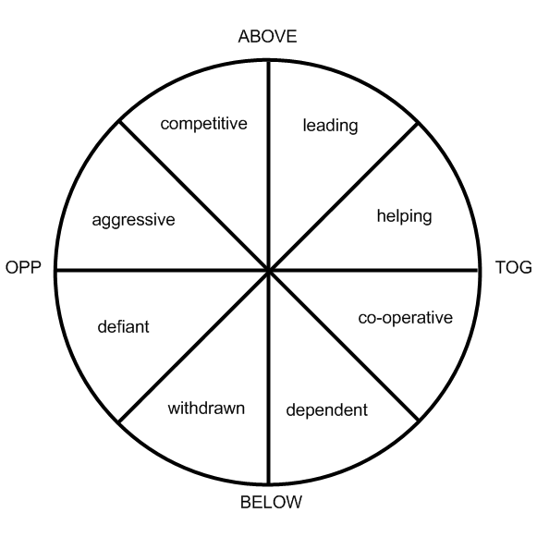Leary’s circle is an interpersonal model where it is possible to graph the type of behaviour you have towards others. There are 2 main axis. One is the power or control axis (above and below) which gives the opposing sides of dominance and submission. The other main axis is love and hate.   
Your personality can be seen as a blending of the two axis. Human traits and the social behaviour of individuals can be mapped within the circle.  
So there can be friendly dominance or hostile dominance; friendly submission or hostile submission. This is a simple explanation and of course it is more complicated.  
For each segment of the circle a personality gets another name blending quantities of dominance and affiliation. Each action of an individual in a given situation shows a different social behaviour and by looking at the opposite on the graft the complementary (following) behaviour of another can be predicted. Ex. Hostile dominance will invoke a reaction of hostile submission.

# Right and wrong

What is right? What is wrong? What is good? What is bad? How do we measure what is right and wrong? How do we construct our values? Values are personal based on personal experience. They are signalled by our unconscious nervous system and give us good or bad feelings.

We go through a cultural learning process as children and older, making adjustments as we grow. Our culture becomes a way of life. It is our security. It is familiar, and become the automatic way to get what we want. We form our values and they become the best and only way of doing things.

An example in the Morning newspapers – 26 November 2007 *“The Dutch are blunt, dominant, egocentric, and control freaks. Dutch are direct and stand-offish. Not clear who is the boss at the workplace”.* (Expatica, 2007)

# Hofstede’s Dimensions

Cultures can be described according to the study of Geert Hofstede. These ideas were first based on a large research project into national culture differences across subsidiaries of a multinational corporation (IBM) in 64 countries. The Hofstede Model of Cultural Dimensions can be of great use when it comes to analyzing a country’s culture. There is however something you have to keep in mind. These averages aren’t related to the individuals of the same country. Although this model frequently demonstrated its correctness looking at the general population, you may not assume that all the individuals, regions and subcultures fit into this same form. (Clearly Cultural, 2009)

Professor Hofstede's four dimensions are:

**Power distance**

Power Distance reflects the degree to which a culture believes how institutional and organizational power should be distributed (equally or unequally) and how the decisions of the power holders should be viewed (challenged or accepted).

[**Individualism**](http://en.wikipedia.org/wiki/Individualism) **vs.** [**collectivism**](http://en.wikipedia.org/wiki/Collectivism)

The degree to which individuals are integrated into groups.

[**Uncertainty**](http://en.wikipedia.org/wiki/Uncertainty) **avoidance**

Uncertainty Avoidance refers to the extent to which a culture feels threatened by ambiguous, uncertain situations and tries to avoid them by establishing more structure.

[**Masculinity**](http://en.wikipedia.org/wiki/Masculinity) **vs.** [**femininity**](http://en.wikipedia.org/wiki/Femininity)

Masculinity-Femininity indicates the degree to which a culture values such behaviours as assertiveness, achievement, acquisition of wealth or caring for others, social supports and the quality of life. T

**Long term orientation vs. short term orientation**

Also know as Confucian Dynamism - It ranges from long term to orientation to short term orientation. Long term oriented societies attach more importance to the future.

# Fons Trompenaars: the car and the pedestrian

*You are a passenger in a car driven by a close friend. He hits a pedestrian. You know that he was speeding. There are no other witnesses. His lawyer (who has clearly forgotten his ethics) says that if you are prepared to testify under oath that your friend was not speeding, it may save him from serious consequences. What would YOU do?*

Fons Trompenaars has written many books regarding intercultural communication aimed at the business community. Some scholars question his research but his books have become accepted wisdom within the business community. If you ask this question of a general group in say, Norway on the one hand and Korea on the other, you are likely to get diametrically opposed answers. And each group will likely be equally as appalled as the other that anybody could think differently. In fact, the breakdown of how people have responded to this question through a whole range of countries is on the next slide

# Edward Hall

Edward T. Hall was an anthropologist who made early discoveries of key cultural factors. In particular he is known for his high and low context cultural factors.

## Hall’s Cultural Contexts

High context: In a high-context culture, there are many contextual elements that help people to understand the rules. As a result, much is taken for granted. This can be very confusing for person who does not understand the 'unwritten rules' of the culture.

Low context: In a low-context culture, very little is taken for granted. Whilst this means that more explanation is needed, it also means there is less chance of misunderstanding particularly when visitors are present.

## Hall’s time dimensions

Monochromic time: M-Time, as he called it, means doing one thing at a time. It assumes careful planning and scheduling and is a familiar Western approach that appears in disciplines such as 'time management'. Monochromic people tend also to be low context.

Polychromic time: In Polychromic cultures, human interaction is valued over time and material things, leading to a lesser concern for 'getting things done' -- they do get done, but more in their own time. Polychromic people tend also to be high context.

# Success factors

* Keep an open mind – be flexible with your opinions
* Have a sense of humour – things will get you upset, angry, annoyed or embarrassed. When possible – laugh.
* Try to cope with failure. It is not necessary to be perfect. It would be surprising if you did not fail at something when you live abroad.
* Be communicative – do not keep things locked in
* Be curious – the only way to find out and learn.
* Be positive and realistic
* Be understanding of differences.
* Express warmth, empathy and respect
* Know yourself.

# Assignments

For completing your portfolio several assignments have to been made through your preparation at home, but also during your period overseas.

## 

## Assignment A: Identity circle

Jabobs, A. (2012). Cross-Cultural Communication. Noordhoff Uitgevers: Groningen.

Read Chapter 1 and 2 of this book and fill in the identity circle (see annex 1) and save it in your personal portfolio (workshop 1 – ID).

How to fill in the identity circle?

A person’s identity is complex and composed of many differing elements. So you are a student but also a son; you belong to a student’s association; your hobbies include playing hockey and war games on the X-Box/Wii; you like hamburgers, listen to hard-rock , you spend hours on Facebook and twitter and you like to watch videos on YouTube, especially horror movies (when nobody is present!).

## Assignment B: Leary’s circle

Fill in the questionnaire on the website http://www.testjegedrag.nl/tjg/zelftest/index.htm

Print the result of the questionnaire and put it in your portfolio workshop1 – Leary’s circle.

## Assignment C: Interview

Look on the YPO website for the contact details of ex YPO students. Choose an ex YPO student who seems interesting and interview her/him.

Write down the answers to the questions below and save it in your portfolio (workshop 1 – interview).

TOPIC of the interview is:

* What were your expectations of what you wished to achieve abroad?
* Were those expectations fulfilled?
* Why or why not?
* Given what you have come to realize about yourself and the people worked/lived with, what is your best advice to me (being an YPO-er) going to work/live in the same environment?

## Assignment D: Own expectations

Now that you have interviewed an ex-YPO student formulate your own expectations, both on a professional and social level.

Social environment: You have given your preferences for locations/housing/social contacts. Do you have a clear picture of what you can expect? Will there be people visiting you (family, close friends)? Have you thought of where they can stay? Which clothes are you going to bring with you? Leisure? Financial matters?

Professional environment: Which position will you have in the organization? How will you be able to communicate with other professionals, volunteers, superiors, clients, workers in the organization?   
What can be the result of your professional activity?  
Length: 1-a4. (font Constantia 12).

## Assignment E: Culture clashes

As YPO ambassadors during your time in the country abroad you are to add to your portfolio 3 examples of situations where cultures clashed. How did you handle the situation? What would you do differently the next time? Formulate advice for future YPO’ers

Reflect on a general model of differing communication styles   
Richard Lewis model:  
Reflect on how others might perceive you   
Video making: give a bad message to your supervisor in the receiving country

**The assignments from this workshop will be discussed during the departure meeting**

# Bibliography

*Changing Minds*. (2012). Retrieved 05 01, 2012, from Hall's cultural factors: http://changingminds.org/explanations/culture/hall_culture.htm

*Clearly Cultural*. (2009, 04 21). Retrieved 05 01, 2012, from Making Sense of Cross Cultural Communication: http://www.clearlycultural.com/geert-hofstede-cultural-dimensions/

*Expatica*. (2007). Retrieved 05 01, 2012, from Expatica: http://www.expatica.com/nl/news/local_news/morning-newspapers--26-november-2007-46328.html

Hofstede, G. (n.d.). *Geert Hofstede*. Retrieved 05 1, 2012, from Geert Hofstede: http://geert-hofstede.com/dimensions.html

Jakobs, A. (2012). *Cross-Cultural Communication.* Groningen: Noordhoff Uigevers.

# 